CSA1411-COMPILER DESIGN

LAB EXPERIMENTS

NAME:- R KALAI AMUDHAN

REG NO:- 192511292

EXPERIMENT – 6:
AIM:-
Develop a lexical Analyzer to test whether a given identifier is valid or not.
CODE:-
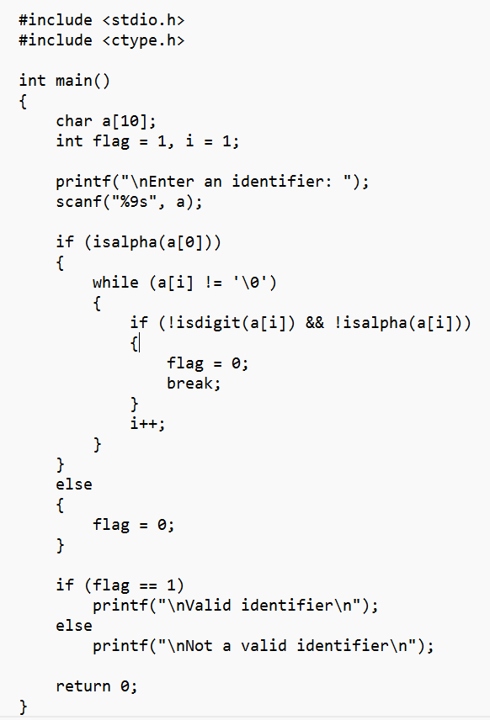
OUTPUT:-
